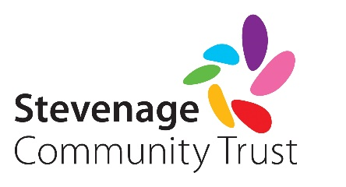
Grant Application Form - Community

SECTION 1: CONTACT DETAILS

Organisation / Group
Registered charity number (if applicable)
Contact names | 1) | 2)
Position (one must be Chair/Secretary/ Treasurer)
Address

Telephone number / mobile number
Email
How did you hear about Stevenage Community Trust?
Please provide a brief description of your group’s local activities

SECTION 2: FINANCIAL INFORMATION

Total cost of equipment/project/activity | £
Amount required from SCT | £
Have you requested funding from any other voluntary/statutory organisation? (please provide details)
Have you undertaken any fundraising activities for this equipment/project/ activity? (please provide details)
If successful, please make payment by: | Cheque / Bank Transfer (please delete as appropriate)
For cheques, make them payable to:

SECTION 3: FUNDING REQUIREMENTS

Please provide details of the equipment, project or activity you require funding. Include clear objectives and expected outcomes, justify why our assistance is needed and the impact if funding is declined.

When will the activity take place / project commence / equipment be purchased?

How will the grant be spent? (please include a detailed breakdown of costs and enclose relevant quotes)

How many residents from Stevenage and its surrounding villages will benefit from the grant? In what way?

If successful, how are you able to publicise the grant from Stevenage Community Trust?

SECTION 4: ANY OTHER INFORMATION

Please use this space to provide any other information to support your application:

SECTION 5: DECLARATION

Please complete the checklist below. Failure to submit all relevant supporting documentation may result in your request being delayed or declined.

- I have enclosed the latest accounts for my organisation YES / NO / NOT APPLICABLE
- I attach proof of the organisations bank account (for payment by bank transfer only) YES / NO / NOT APPLICABLE
- I have enclosed quotes for equipment or services relating to the application YES / NO / NOT APPLICABLE
- The organisation has a child and vulnerable adult protection policy in place YES / NO / NOT APPLICABLE

I confirm that the information in this application is correct to the best of my knowledge. I understand that any grant awarded must only be used for the purpose it was intended, and agree to comply with any conditions that Stevenage Community Trust may attach to it.

Signed …………………………………………………….. Date ……………………………………………………………………….

Once complete, please return to: Stevenage Community Trust, Stewart House, Primett Road, Stevenage, Herts, SG1 3EE or email to grants@stevenagecommunitytrust.org

